Healthy lunchbox ideas for busy moms to help growing kids get the protein and nutrition they need, without stress.

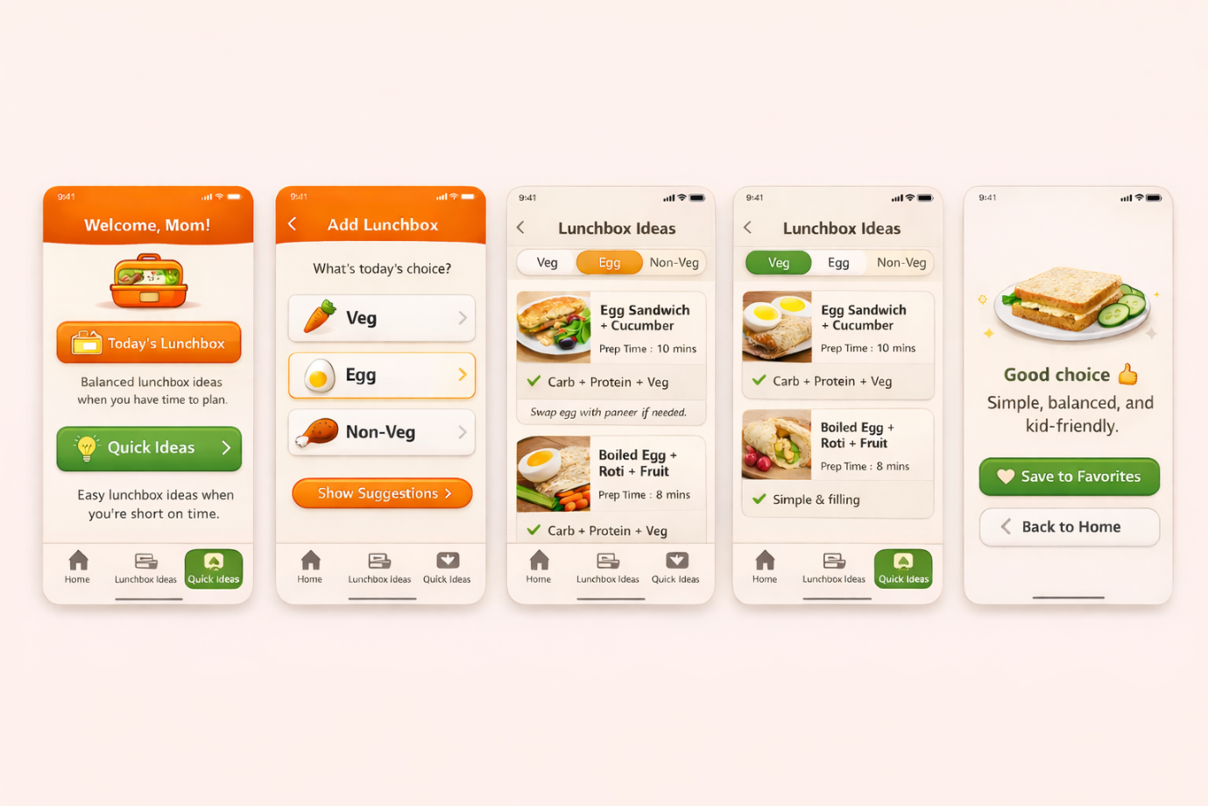

📱 APP DISCLAIMER (SIMPLE & FRIENDLY)
You MUST include this (it protects you legally and emotionally).
This app provides general food ideas for kids. It does not replace medical or professional nutrition advice. For specific health concerns, please consult a qualified professional.

A) 📐 WIREFRAME CHECKLIST (SCREEN BY SCREEN)
Use this as the design blueprint.
1️⃣ Home Screen
- Header: Welcome, Mom!
- Button 1: Today’s Lunchbox
  - Subtitle: Balanced lunchbox ideas when you have time to plan.
- Button 2: Quick Ideas
  - Subtitle: Easy lunchbox ideas when you’re short on time.

2️⃣ Today’s Lunchbox → Preference Screen
- Title: What’s today’s choice?
- Buttons:
  - Veg
  - Egg
  - Non-veg
- CTA: Show Suggestions

3️⃣ Lunchbox Suggestions Screen
- Show only 3 ideas
- Each card includes:
  - Dish name
  - Protein source (1 word)
  - Prep time
  - ❤️ Save
  - ⬜ See Recipe

4️⃣ Recipe Screen (Optional)
- Title: Dish name
- Section: Quick Steps (2–3 bullets)
- Section: Tips
- If free → preview + paywall
- If paid → full recipe

5️⃣ Quick Ideas Screen
- Text at top:
Short on time? These lunchbox ideas are quick, simple, and protein-rich.
- List of no-cook / minimal-cook ideas
- Show protein + time only

6️⃣ Favorites Screen
- Saved ideas list
- Free users: limited saves
- Paid users: unlimited

7️⃣ Weekly Summary (Optional)
- Message: Great job, Mom!
- Soft encouragement
- Optional upgrade CTA

